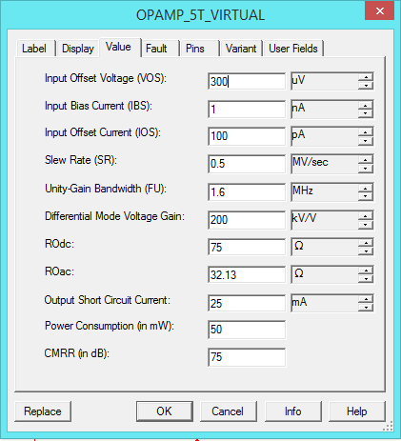

|  |  |  |  |  |  |  |  |  |
| --- | --- | --- | --- | --- | --- | --- | --- | --- |
| 2 Результаты моделирования ИОУ-2 | | | |  |  |  |  |  |
| Вариант | | Uвх=V4 (мВ) | R5, кОм | Uвых (V3= -Ec) | Uвых(V3=0) | Uвых(V3=2хЕс) | Кс | КОСС |
| 1 | R2=R2min | UД | 14 | -3,814 | -3,624 | -3,962 | 1,450 | 47,960 |
| 2 | R2=R2nom | UД | -3,691 | -3,568 | -3,841 | 1,400 | 48,110 |
| 3 | R2=R2max | UД | -3,579 | -3,516 | -3,668 | 1,350 | 48,290 |
| 4 | R2=R2max | -UД | 3,628 | 3,553 | 3,730 | 1,370 | 48,260 |